Aug



UNITED CHURCH OF CHRIST

**LOCAL CHURCH PROFILE**

**First Congregational Church of Western Springs**

**Western Springs, IL**

**Senior Pastor**

Illinois Conference, Chicago Metropolitan Association

August 16, 2024

LOCAL CHURCH PROFILE CONTENTS

* Position Posting
* Who Is God Calling Us To Become?
* Who Are We Now?
* Who Is Our Neighbor?
* References
* Consent and Validation

*“God is able to provide you with every blessing, so that*

*having all sufficiency in all things at all times,*

*you may abound in every good work.”*

*(2 Corinthians 9:8)*

INSTRUCTIONS

The new Local Church Profile supports the calling and discernment of United Church of Christ congregations with their current or future pastoral leadership.

For many congregations, the interim time between ministers is an intentional season that is guided in part by the preparation of a Local Church Profile. Using the Profile, the church can discover its data and express its story for the reliable discernment of a search committee and the beginning of a new pastorate. Searching ministers will want to see this document in its entirety.

The interim season is not the only time in a church’s life when it’s valuable to give attention to explore a congregation’s vocation. Three sections of the Local Church Profile – WHO ARE WE NOW, WHO IS OUR NEIGHBOR, and WHO IS GOD CALLING US TO BECOME – are meant to be updated every 3-5 years. Known together as the “Discovery Document,” these three sections can be completed by a visioning group, a governing body, a transition team, or other group – not just the search committee – in order to draw forward the gifts and imaginative possibilities of a congregation. The church’s engagement with the “Discovery Document” might not have the same sequence as the completed Local Church Profile that is read by candidates.

Some questions are easy to answer. Some are not so easy. Prompts are provided to stimulate narrative response if needed; these italicized prompts are merely examples from which to choose or to inspire your own. Efforts to answer the questions will prompt conversations and explorations and story-tellings and many prayers. As the Spirit moves throughout the process, congregations will shape a collective articulation of Christ’s leading (WHO IS GOD CALLING US TO BECOME). This last question to be answered becomes the first section to be read by searching ministers in the Local Church Profile, and it is boldest and most actionable piece for faithful leadership into the future.

Your conference can provide materials referenced in the Local Church Profile, such as the 11-Year Report containing data as reported by your congregation annually to the UCC Data Hub, and MissionInsite reports containing demographic information on your community. More information on types of pastorate in the United Church of Christ can be found in the Call Agreement Workbook. Be sure to use the Call Agreement Workbook’s Scope of Work to describe in this Local Church Profile the position being sought.

When it is time for ministerial search, the conference can counsel you on posting the Local Church Profile together with your public listing at UCC Ministry Opportunities (http://oppsearch.ucc.org).

The last page of the Local Church Profile contains a statement that parallels the consent statement signed by ministers in the UCC Ministerial Profile. In keeping with the covenantal relationship between a church and those it seeks to call, this statement encourages an open, honest exchange of information. On behalf of the United Church of Christ, and on the basis of the best knowledge available to them, your conference staff will validate your completed Local Church Profile when it is ready to be shared in relationship with prospective new leaders.

**1. POSITION POSTING**

a. LISTING INFORMATION

b. SCOPE OF WORK

c. COMPENSATION & SUPPORT

d. WHO IS GOD CALLING TO MINISTER WITH US?

1a. LISTING INFORMATION

Church name: First Congregational Church of Western Springs

Street address: 1106 Chestnut St, Western Springs, IL 60558

Supplemental web links: [**https://www.wscongo.org/worship/**](https://www.wscongo.org/worship/)

Additional ecumenical affiliations *(e.g. denominations, communions, fellowships)*:

We are in fellowship with the LaGrange Area Ministerium which includes churches in LaGrange, Western Springs, LaGrange Park and Brookfield, and includes chaplains at the area hospitals and senior living residences such as Plymouth Place.

Conference: Illinois Conference

Association: Chicago Metropolitan Association

UCC Conference or Association Staff Contact Person (Name, Title, Phone, Email):

Rev. Shernell Edney Stilley

1840 Westchester Blvd

Suite 200

Westchester, IL 60154

(708) 344-4470

Shernelledneystilley@ilucc.org

Summary Ministry Description:

*In a short paragraph, reflect on where your church is going and what it might look like when you get there. What do you need to get there? Who are you seeking to join you on this part of your church’s faith journey?*

As we envision the future of our church, we see a vibrant community that truly embodies the love of Christ amongst our own congregation, while actively engaging in meaningful mission and outreach ministries that make a positive impact on our local, national, and global neighbors. Our aspiration is to create a nurturing environment where children and families can learn about their faith in an inviting and supportive atmosphere, fostering a deep sense of discipleship that flourishes naturally within our church family. To bring this vision to fruition, we need a Senior Pastor who can inspire, organize, and lead a committed team of clergy, staff, and lay leaders, all of whom share a passion for our mission and can motivate our congregation to willingly serve and share their gifts. We are looking for a Pastor who is progressive and embraces diverse perspectives while being firmly rooted in the teachings of Christ. This individual should possess strong leadership, preaching, and communication skills, enabling them to inspire and guide our congregation toward our mission-driven goals. With our rich history in mind, we seek a Pastor who is dedicated to children’s ministry, strong intra-church programming and activities, welcoming to everyone, and committed to fostering a vibrant church community that encourages active participation in the church and its service and mission outreach ministries on a local, national and global level.

Photographs:

*Insert 1 – 3 images of your church, its people, its parsonage or building or gathering space, etc.*

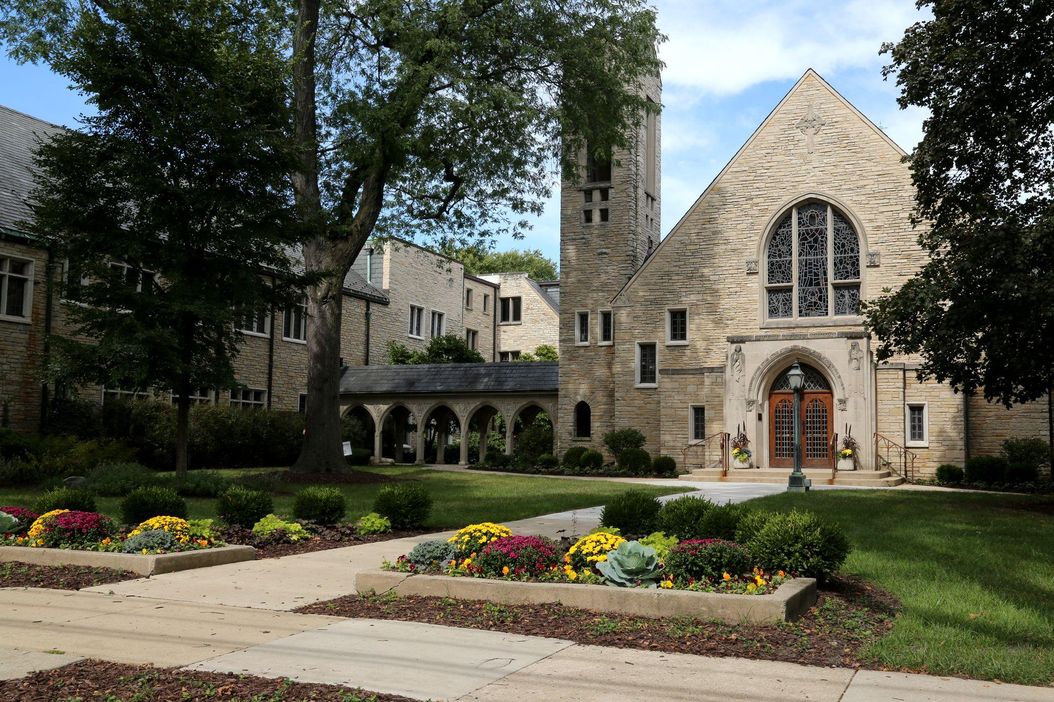

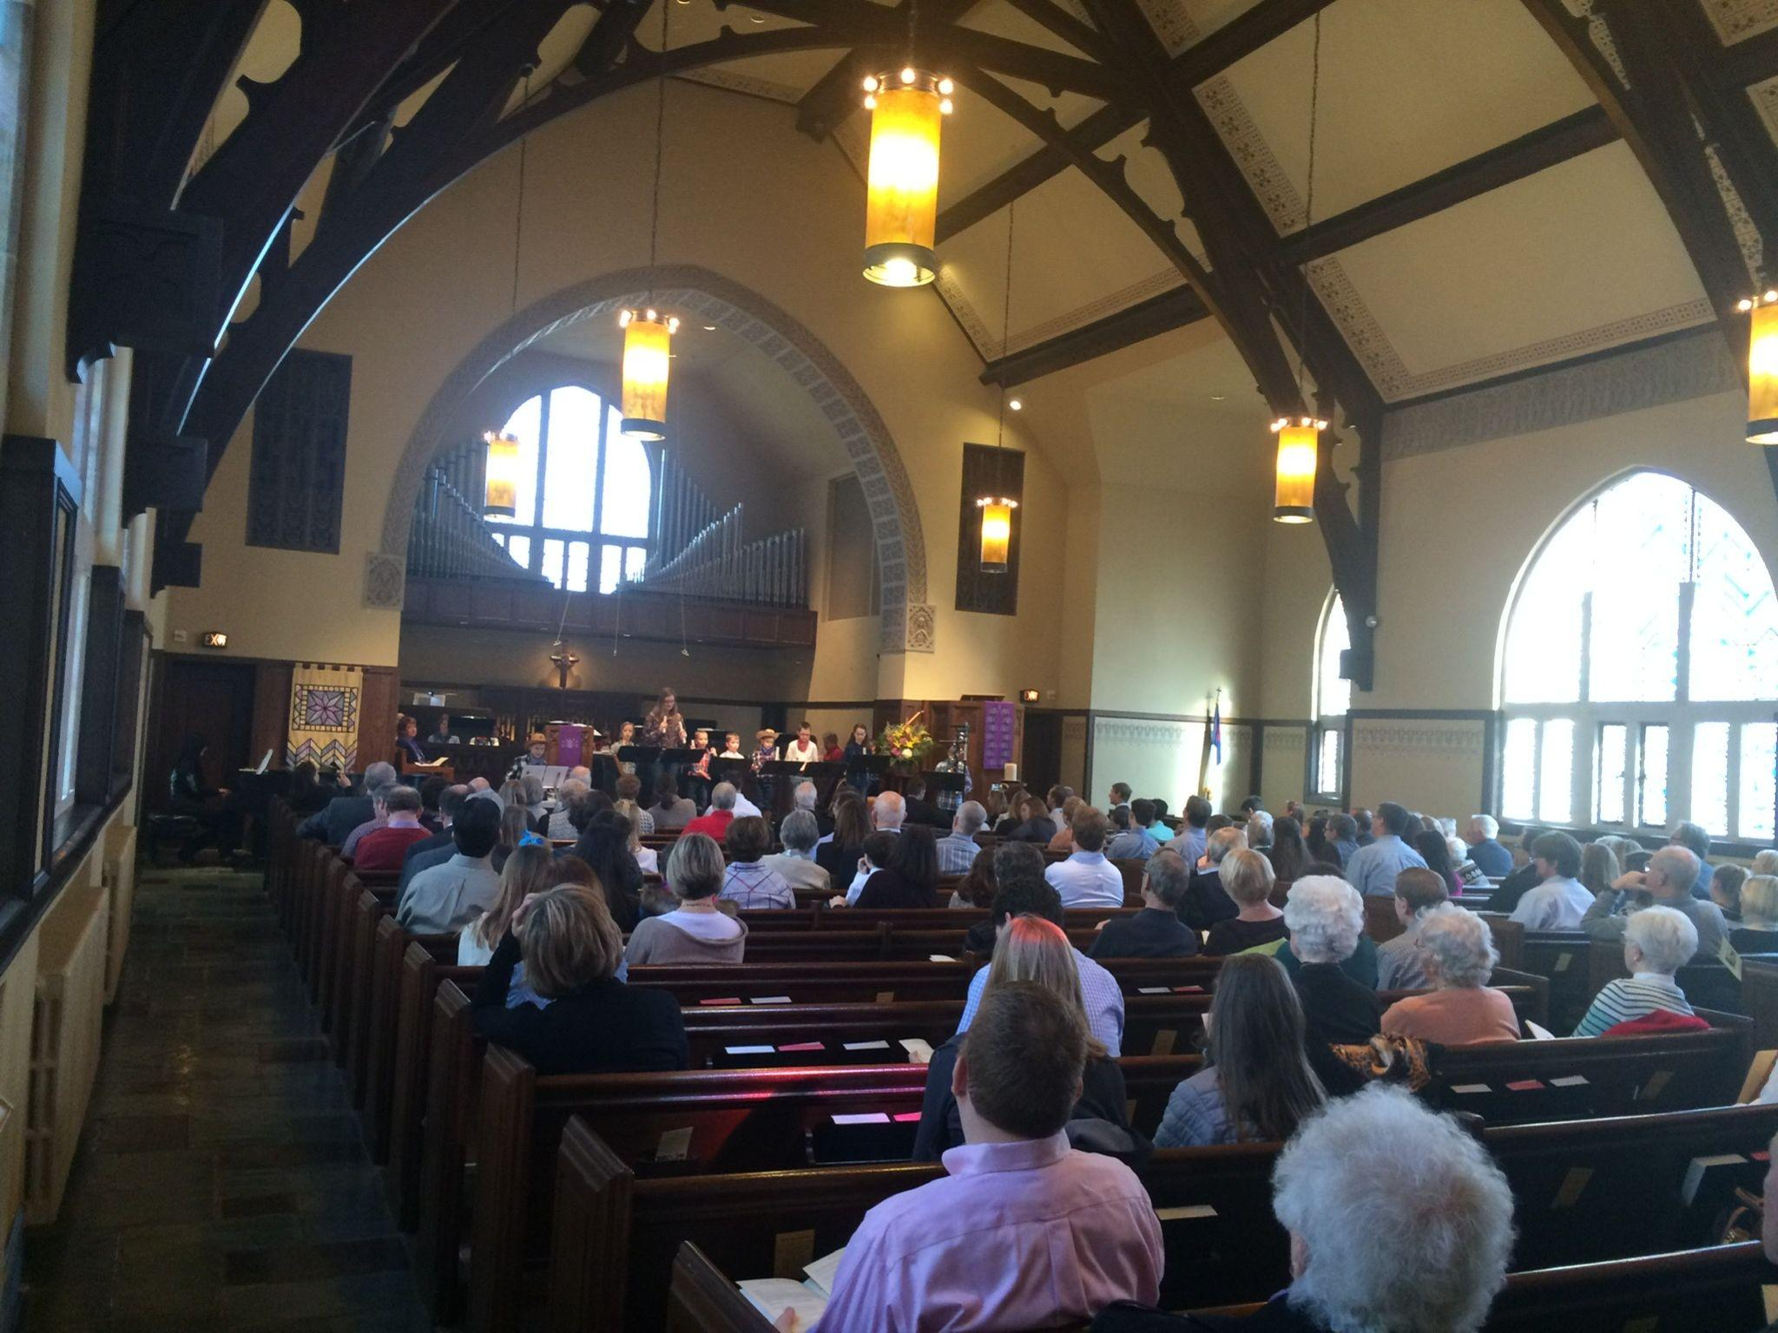

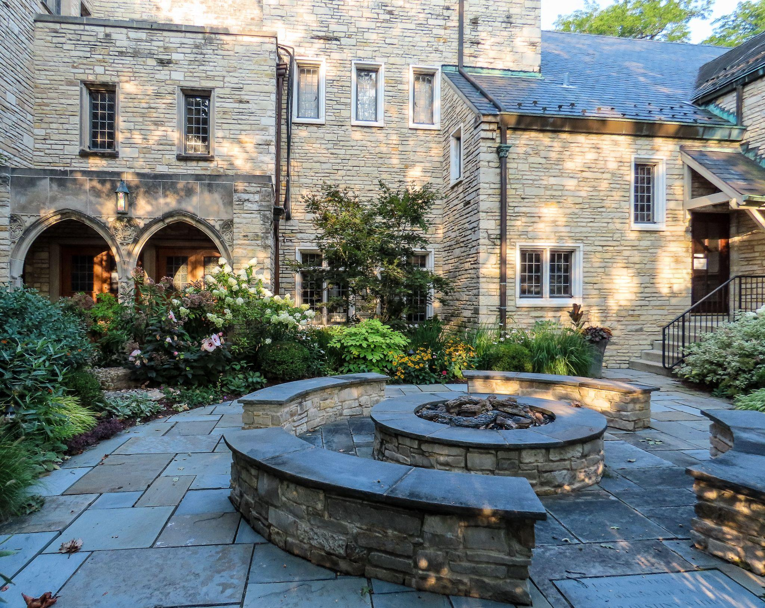

What we value about living in our area (2 – 3 sentences): The church is located in a vibrant and close knit community. We value our great schools, and our proximity to Chicago and the vast array of culturally diverse activities that it offers.

Current size of membership: 1348

Languages used in ministry (other than English): None.

Position Title: Senior Pastor

Position Duration (choose one, delete the other options listed):

Settled – a called position intended for longer-term ministry in which the minister moves church membership to the congregation and moves standing to related association

Compensation Level (choose one, delete the other options listed): Full Time

Does the total support package meet conference compensation guidelines? Total compensation is negotiable and will be commensurate with the years of experience, skills and abilities of the selected candidate.

1b. SCOPE OF WORK

*(add here the Scope of Work developed by your church using the Call Agreement Workbook)*

Reporting to the Executive Committee and Church Council, the Senior Pastor will serve as the senior spiritual leader for our Church providing pastoral support and direction to all members of both the congregation and staff. In conjunction with the Executive Committee and Church Council, they will also oversee all elements (strategic and day-to-day) of the Church’s operations, business, human resources and financial affairs. First and foremost, our Senior Pastor will lead all elements of spiritual growth, faith formation and welfare across our church community, helping the congregation determine where God is leading each one of us as peoples in Christ. Equally important will be our Pastor's ability to lead and manage an organization in a people-, financial- and systems-oriented manner.

Core Competencies:

*(List three core competencies that you imagine could be foundational in your next minister’s relationship with the church. For example, a church seeking a pastoral care minister might hope to call someone who is caring, sensitive and sociable, while a church seeking an executive minister might want an organized, detail-oriented and time-conscious person.)*

Passionate and Spirit-filled - an ability to excite and engage our congregation where they are in their spiritual and life journeys in an empathetic manner - through preaching, education, programming and pastoral care.

Strategic and Visionary - an ability to develop, guide/advance and execute a compelling strategic plan/vision for the church.

Management Focused - an ability to set strategy into motion, communicate the part that others will play and oversee the development of systems and procedures to support the Church’s vision.

1c. COMPENSATION AND SUPPORT

Compensation: Total compensation is negotiable and will be commensurate with the years of experience, skills and abilities of the selected candidate.

Salary, Housing Allowance and Benefits: Salary and housing allowance plus full array of benefits offered through the UCC.

What is the expected living situation for your next minister *(e.g. parsonage, living nearby with a housing allowance, living elsewhere to commute as needed)*?

We expect the selected candidate to live within a reasonable proximity of our Church and the Western Springs community. While we no longer have a parsonage, we do have a modest fund available to lend in the form of a mortgage.

Comment on the residential/commuting expectations for your next minister.

The community of Western Springs is a wonderful community and a great place to call home. Equally attractive, and abutting Western Springs, are the villages of La Grange, La Grange Park, La Grange Highlands, Countryside and Indian Head Park. All elementary and middle schools in Western Springs and these abutting collar communities feed into Lyons Township High School District 204, a highly regarded Illinois High School. Other reasonably close West Suburban Cook County communities, including Brookfield, Riverside and Westchester, offer lovely neighborhoods and good schools as well.

State any incentives *(e.g. school debt reduction or retention bonus after a certain number of years in position)*:

The Church’s Time-Off policy provides paid time off beginning at 20 days per year, paid Sabbatical leave of two months every five years (in addition to vacation), and paid maternity and parental leave. The church budget currently allows for partial cell phone reimbursement, and an allowance for continuing education and development, for each pastor.

Describe peer and professional supports available for ministers in your association/conference:

Our clergy participate in a number of supportive ministries, some examples are, spiritual direction, in person and online clergy groups, attending the UCC senior pastors' conference, local ministerium, hosting this year's Illinois Conference annual meeting and many other connections and ministries

If applicable, describe how your church will adopt part-time adjustments in the pastoral schedule to support a minister’s bi-vocational employment: Not applicable.

1d. WHO IS GOD CALLING TO MINISTER WITH US?

Describe the ministry goals you envision your next minister co-collaborating with the congregation to achieve.

* Enhancing our engagement with our young family population while still meeting the needs of other more traditionally active generations.
* Increase opportunities for diverse worship (including online) while respecting the traditions many of our members hold dear.
* Communicating with and supporting the congregation through change - as change seems to be the constant in the world right now and our church is full of people with diverse convictions.
* Continue to create an atmosphere of extravagant hospitality so everyone has a place and everyone feels welcome.

Describe how your vision of the minister you are now seeking will assist the congregation in making an impact beyond its walls.

Ministering to the broader community, locally, nationally and globally, has always been one of the primary missions of this congregation. The new Senior Pastor can assist in this ministry by becoming familiar with our numerous mission partners and preaching the gospel of caring for our neighbors. They will also make an impact through their example – helping at our rummage sale, volunteering with some of our mission partners, and getting to know other community leaders such as government officials and school administrators, for example. The new Senior Pastor will also be influential in helping the congregation decide how to allocate stewardship dollars, including the percentage of the budget dedicated to ministry beyond our walls.

Specify language requirements or culturally-specific capacities preferred in a next ministerial leader, and why those matter to the congregation’s sense of calling.

English is the primary language

Based on what you have learned about who your church is, who your church’s neighbor is, and who God is calling the church to become, describe four areas of excellence from *The Marks of Faithful & Effective Authorized Ministry* that your next minister will display to further equip the congregation’s ministry in these areas.

* Exhibiting a commitment to lifelong spiritual development and faithful stewardship.
* Leading faith formation effectively across generations.
* Experiencing and appreciating a variety of theological perspectives.
* Practicing the radical hospitality of God.

**2. WHO IS GOD CALLING US TO BECOME?**

“You shall love the Lord your God with all your heart, and with all your soul, and with all your mind.” (Matthew 22:37 NRSV)

Who is God calling you to become as a congregation?

Our Mission Statement is our guide:

* To worship God together in wonder and in faith
* To increase our love of God by increasing our love of neighbor
* To connect the stories and truths of Scripture with our daily lives
* To share our stories of faith with one another and with our community
* To open our lives to the transforming power of God’s love
* To celebrate the liberation received through Christ’s forgiveness and to share that gift by forgiving others
* To follow Christ to the side of all who suffer and despair
* To be Christ’s messengers and advocates for social justice
* To be generous and thoughtful stewards of all God’s gifts
* To welcome all people as children of God

Describe how God is calling you to reach out to address the emerging challenges and opportunities of your community and congregation.

*For example, describe two experiments your congregation has initiated or engaged in the past year, what were the results and where do you see your next steps? Has your church had a multi-year strategic plan or vision statement; if so, where do you see that plan/vision taking you?*

Our congregation is located in an upper-middle class neighborhood, where members have the privilege of not experiencing things like family members being incarcerated. During this past year, we have partnered with an organization called Companions Journeying Together to recruit congregation members to become pen pals with imprisoned individuals. We currently have 13 members serving as pen pals to individuals incarcerated in the state of IL. Members are learning more about the difficulty these individuals face every day, the economic, family and social factors that can lead to imprisonment, and compassion for individuals they might never have another opportunity to learn from and interface with. We are hoping to share these experiences with others in the congregation to recruit more and more pen pals. And, we’re offering opportunities for members to sign Christmas cards to raise further awareness. We’re also hoping, with COVID restrictions now lifted, that we may be able to recruit some members to make personal visits to imprisoned people as well.

Another new ministry has been developed to offer support to Moms of Complex Kids (children/youth with any mental health diagnosis, including neurodiversity, suicidal ideation/attempts, eating disorders, etc.). We have worked for several years to try and reduce the stigma around mental health. After noticing that several moms were coming to our ministers for pastoral support regarding their children, one of our pastors began a support group specifically to support these parents. Confidentiality was a huge concern for the participants, and so members joined primarily by word of mouth. The group has become more comfortable with announcing to the greater membership that this group exists and once we announced it, 6 new members have joined. Next steps include continuing to welcome more participants, including parents who may not be members of the church.

This congregation has been faithful in doing multi-year visioning for decades. The last strategic vision was completed about 8 years ago, and included discerning the Mission Statement above.

The congregation has just completed an All-Church survey conducted by Holy Cow Consulting. Four hundred twenty-five individuals completed the survey. We are in the process of reviewing this information and look forward to the new Senior Pastor joining with us to discern God’s call for our congregation in this time and place.

**3. WHO ARE WE NOW?**

“You shall love your neighbor as yourself.” (Matthew 22:39 NRSV)

a. CONGREGATIONAL REFLECTIONS

b. 11-YEAR REPORT

c. CONGREGATIONAL DEMOGRAPHICS

d. PARTICIPATION AND STAFFING

e. CHURCH FINANCES

f. HISTORICAL INFORMATION

3a. CONGREGATIONAL REFLECTIONS ________

Describe your congregation’s life of faith.

*For example, what beliefs and commitments are stated in your congregation’s purpose statement or membership vows? How is God most often described in worship liturgy? In what ways would you describe the Holy Spirit in your midst?*

Our beliefs and commitments are best described in our Mission Statement (see above at top of section 2) Covenant of Inclusion and 3) Membership vows below:

Covenant of Inclusion

We, the First Congregational Church of Western Springs, United Church of Christ, strive to be people of extravagant welcome. We affirm that all people are created in the image of God, and we celebrate the diversity of God’s creation.

As we seek to become faithful disciples of Jesus Christ and endeavor to live out our shared mission, we respect and gladly receive persons of every race, ethnicity, nationality, gender, gender identity and expression, sexual orientation, mental and physical ability, age, socioeconomic status, marital standing and family structure, and religious background.

We affirm that the Holy Spirit gathers us as a congregation in which all persons are invited to participate in the life, leadership, ministry, fellowship, worship, sacraments, responsibilities, blessings, concerns, and joys of our community of faith. We hope and pray that by establishing and embodying this covenant of inclusion, we might fully follow Christ’s commandment to love God and neighbor and be a safe place where God’s love abounds.

New Member Litany (excerpts)

New members:

“Confessing, or renewing, our faith in God and our loyalty and devotion to Jesus Christ, we now enter into the membership of this church, seeking the guidance of the Holy Spirit into all truth. We covenant and engage to walk with you in the fellowship of the gospel and in the ways of the Lord made known or to be made known to us. We take this church to be our church, promising so far as in us lies, to share its work, sustain its worship, love its members and seek its unity, purity, and increase.”

The congregation:

“We then affectionately welcome you as members with us of the Church of Christ, joining and rejoicing with you in your profession. We share with you its work and worship and world-wide vision, promising you such fidelity in Christian love as you have promised.”

Covenant promise of old and new members

“We covenant with the Lord and one with another, and do bind ourselves in the presence of God, to walk together in all his ways, according as he is pleased to reveal himself unto us in his blessed word of truth.”

How is God referred to in liturgy?

Many descriptive words for God are used in our worship services, such as Gracious and Loving God, Creator God, Parent God, Holy One, Beloved, Generous God, etc. We try to stay away from gendering God, but do refer to God as both male and female.

In what ways would you describe the Holy Spirit in your midst?

The answer to this question depends on who you ask! Some members would say it’s a feeling deep in their soul that they know and trust that they are loved by God; another member might say it’s when they are moved to tears by a piece of beautiful music; another would say it’s when a pastor or lay member brings them a prayer and a casserole.

Describe several strengths or positive qualities of your congregation.

* Fully embraces mission and outreach and is committed to helping those locally and internationally.
* Strong commitment to relationship-building.
* Flexible - especially for a church that values its traditions.
* When asked, people step up and help.

Describe what worship is like when your congregation gathers.

*For example, where does worship take place, and what is it based around? What was a recent baptism like? What are some words used to describe good preaching?*

Most of our worship services take place in our main sanctuary. But we also have a chapel where we also hold smaller worship services, including, for example, an Advent Taizé service. Contemplative and Vesper worship services are held in the evening via Zoom. We hold a Stations of the Cross service in our Fellowship Hall where a labyrinth is tiled in the floor. Our primary Sunday morning worship services are usually based on the Gospel reading for the morning, often from the lectionary but can also be chosen by the preacher of the day. We have also utilized sermon series resources such as Sanctified Art, particularly during Advent and Lent.

Our most recent baptism was for a brother and sister. The sister was younger and quite intrigued by the whole sacrament and was baptized willingly and joyfully. The brother, on the other hand, refused to come to the pastor and was not happy about the water on his forehead. Baptisms are always a joyful moment in the midst of worship, though, and the congregation always promises their love, support and care to the one(s) being baptized. We also most often invite the children in the congregation to gather at the foot of the font to witness the baptism up close!

Good preaching – always includes the Good News, is spoken in such a way that is clear to hear and understand, includes interesting teaching, but has some humor or light moments at least once in a while. The best preachers also come to understand the context in which they are preaching and will appreciate how a message may or not be received by the congregation – they know their audience. Good preaching also has inclusive language.

Describe the educational program/faith formation vision of your church.

*For example, how are young people in leadership? How do people continue to form their faith over a lifetime? Name a topic studied or curriculum used recently; what was the impact of this study on those who attended?*

Faith formation and education is another strong priority of this congregation. We are reminded of our ancestors during the Great Depression who, when faced with not being able to pay the mortgage, cut the salary of the Senior Pastor but refused to cut the budget for children’s education, and also increased the mission giving budget. This is our legacy and one we try to honor to this day.

We house a preschool, and have a robust Sunday School program, annual confirmation classes for 8th graders, junior high and high school youth groups, children’s vocal and bell choirs, numerous book and Bible studies for adults, and adult faith formation offerings on Sunday mornings. Youth have leadership responsibility in many of these, including serving as Sunday School teachers and officers in the high school youth group.

Two of our women’s book groups recently read and discussed The Light We Give – How Sikh Wisdom Can Transform Your Life, by Simran Jeet Singh. While learning about the Sikh religion, this study also called participants to consider how they actively live their Christian faith. Responses from participants included: “The book provided an opportunity to hear other peoples’ thoughts and experiences. It also made me put myself in someone else’s shoes and try to imagine the prejudices the author endured with such grace and dignity.” “The book provided me with information about other faith practices and how these could help me in understanding and loving others.” “Truly the adventure of learning more about the Sikh faith and way of life opened my eyes to another way of demonstrating love for God and its implications in the real world. The similarities in the worlds’ religions are extraordinary and demonstrate the very human need to believe in a higher power.”

When asked how First Congo helps members form their faith over a lifetime, we received feedback like this: “Our church is a living faith Congregation. Our Clergy, Christian Educators and fellow Congregants provide the scriptural resources to build our understanding of God and how belief in the Holy One enriches our lives. We also have many opportunities to take our Faith into the world through church stewardship and compassionate service to those in need. As children of God, our living faith grows as we do and opens our eyes to the world.” And, “Being that I have been coming to this church my entire life, I would say at each stage of my life I have found different communities within the church to get involved with that have kept me connected to the church. Being in these different groups has allowed me to grow my faith in both the conversations we’ve had as well as the books that we have studied, helping me to grow deeper in my faith and become a better version of myself.” And, “Even as I am closer to the end of my lifetime and only participating in this church less than two years, it is incredibly valuable to belong to small groups. Being part of a community where issues of all sorts are discussed in safety is vital to continuing to develop my faith.”

Describe how your congregation is organized for ministry and mission.

*For example, how are decisions communicated in your church? How are teams or committees organized? Where does your church struggle for vision?*

We have eight standing committees designated in our church constitution, and several additional non-constitutional committees. (See next question for info on meetings.) The Church Council is where people can hear all of the committee reports each month. Additionally, our communications team sends a weekly email on Wednesday morning that describes important committee decisions in addition to other church news. On Sunday morning, important information is again shared with the congregation.

When it comes to decision-making, how many hours are spent in meetings per month?

There is one major meeting night per month, which typically occurs on the 3rd Monday. The constitutional committees meet for 60-90 minutes (e.g., finance, executive committee, properties, outreach, etc.) The Senior Pastor splits time between Executive Committee and Finance. After the constitutional committees meet, Church Council meets for an hour. Council is open to anyone. However, the voting members include the Executive Committee, Senior Pastor and all constitutional committee chairs. Several staff attend council but are not voting members.

Think of a time when action had to be taken quickly, for example when a crisis or disaster occurred. How was that accomplished?

We recently had a pipe burst and sections of the Education Building flooded. The Senior Pastor worked hand in hand with the properties committee, the head of facilities and the director of operations to assess damage, connect with insurance, develop a plan for repairs and steer work to bring the church back to its current state. Throughout this process, the Senior Pastor worked with the communications team and the Moderator to keep the church updated on the status of repairs, which parts of the building were safe to enter and what was needed to bring the church back to its previous state.

Can you provide the next minister with a copy of an organization structure, bylaws and/or annual report to further explain the patterns of the church’s activity and governance?

Yes, we have an organizational chart and church constitution (updated in 2021) which we can share.

3b. 11-YEAR REPORT

*(add here the 11-Year Report developed with the help of your conference staff, UCC Data Hub, and MissionInsite)*

|  |  |  |  |  |  |  |  |
| --- | --- | --- | --- | --- | --- | --- | --- |
| Church # 164220 |  |  |  |  |  |  |  |
| Assoc. 204 |  |  |  |  |  |  |  |
|  |  |  |  |  |  |  |  |
| Year | Average Weekly Attendance (incl. Livestream) | Starting Membership Number | Deaths | Confirmed | New Members | Unengaged | Ending Membership Number |
| 2019 |  | 1105 | 8 | 30 | 36 | 15 | 1148 |
| 2020 | 369 | 1148 | 9 | 27 | 31 | 27 | 1170 |
| 2021 | 253 | 1170 | 13 | 22 | 44 | 3 | 1220 |
| 2022 | 288 | 1220 | 13 | 33 | 36 | 18 | 1258 |
| 2023 | 327 | 1258 | 14 | 33 | 43 | 3 | 1317 |
| 2024 thru 6/30 | 281 | 1317 | 5 | 23 | 18 | 5 | 1348 |

|  |  |  |  |  |  |  |  |  |  |  |
| --- | --- | --- | --- | --- | --- | --- | --- | --- | --- | --- |
| Year | Current Expenses | Capital Payments | Basic Support | Total Other UCC Giving | Total OCWM | Other Gifts | Wider Mission | Basic Supp% Curr Local | Total Expend | Pledges and Offerings |
| 2019 | $ 1,367,152 | $ - | $ 14,000 | $ 19,000 | $ 33,000 | $ 132,000 | $ 165,000 | 0.010 | $ 1,532,152 | $ 1,133,507 |
| 2020 | $ 1,366,917 | $ - | $ 14,000 | $ 19,000 | $ 33,000 | $ 142,000 | $ 175,000 | 0.010 | $ 1,541,917 | $ 1,120,583 |
| 2021 | $ 1,429,592 | $ - | $ 14,000 | $ 21,500 | $ 35,500 | $ 139,500 | $ 175,000 | 0.010 | $ 1,604,592 | $ 1,190,772 |
| 2022 | $ 1,489,120 | $ - | $ 12,000 | $ 15,000 | $ 27,000 | $ 148,000 | $ 175,000 | 0.008 | $ 1,664,120 | $ 1,228,292 |
| 2023 | $ 1,477,289 | $ - | $ 12,000 | $ 15,000 | $ 27,000 | $ 148,000 | $ 175,000 | 0.008 | $ 1,652,289 | $ 1,218,643 |
| 2024 Budget | $ 1,522,648 | $ - | $ 12,000 | $ 15,000 | $ 27,000 | $ 148,000 | $ 175,000 | 0.008 | $ 1,697,648 | $ 1,269,000 |

3c. CONGREGATIONAL DEMOGRAPHICS ____

Describe those who participate in your church.

|  |  |  |
| --- | --- | --- |
|  |  | *Is this number an estimate? (check if yes)* |
| Number of active members: | 1090 | yes |
| Number of active non-members: | 140 | yes, and includes unconfirmed children |
| Total of church participants (sum of the numbers above): | 1230 | yes |

Percentage of total participants who have been in the church:

|  |  |  |
| --- | --- | --- |
|  |  | *Is this number an estimate? (check if yes)* |
| More than 10 years: | 640 | yes |
| Less than 10, more than 5 years: | 395 | yes, and includes unconfirmed ages 5-10 |
| Less than 5 years: | 195 | yes |

Number of total participants by age:

|  |  |  |  |  |  |  |  |  |  |
| --- | --- | --- | --- | --- | --- | --- | --- | --- | --- |
| 0-11 | 12-17 | 18-24 | 25-34 | 35-44 | 45-54 | 55-64 | 65-74 | 75+ | *Are these numbers an estimate? (check if yes)* |
| 100 | 125 | 125 | 135 | 130 | 170 | 170 | 130 | 145 | yes |

Percentage of adults in various household types:

|  |  |  |
| --- | --- | --- |
|  |  | *Is this number an estimate? (check if yes)* |
| Single adults under 35: | 5 | yes |
| Households with minors: | 56 | yes |
| Single adults age 35-65: | 2 | yes |
| Joint households with no minors: | 25 | yes |
| Single adults over 65: | 12 | yes |

Education level of adult participants by percentage: *We do not collect*

|  |  |  |
| --- | --- | --- |
|  |  | *Is this number an estimate? (check if yes)* |
| High school: |  |  |
| College: |  |  |
| Graduate School: |  |  |
| Specialty Training: |  |  |
| Other (please specify): |  |  |

Percentage of adults in various employment types: *We do not collect*

|  |  |  |
| --- | --- | --- |
|  |  | *Is this number an estimate? (check if yes)* |
| Adults who are employed: |  |  |
| Adults who are retired: |  |  |
| Adults who are not fully employed: |  |  |

Describe the range of occupations of working adults in the congregation:

We have a very diverse set of occupations represented in our congregation, but the majority of adult members have at least some post-secondary education and trend toward white-collar occupations.

Describe the mix of ethnic heritages in your congregation, and the overall racial make-up. Most UCC congregations tend to describe themselves as “diverse.” Yet, the vast majority of UCC congregations are mono-cultural. What does diversity mean in your context?

Our congregation is predominately white (non-hispanic). Our motto is "Diverse in thought, united in Christ." It accurately represents our hope to be an open hearted and open-minded Christian community. We are a congregation that is growing both younger and older, diverse in our perspectives and theology, but are genuinely united in a belief that a loving God, made flesh in Jesus, can transform our world, community and our hearts.

Has your congregation recently had a conversation about welcoming diversity, or do you plan to hold one in the near future (perhaps using, for example, the Welcoming Diversity Inventory)? Please note the date. Comment after the exercise:

We recently introduced an education program around inclusivity culminating in becoming an open and affirming church.

3d. PARTICIPATION AND STAFFING

Complete the following chart. Please leave blank any fields that are not applicable to your congregation.

|  |  |  |
| --- | --- | --- |
| Ways of Gathering | Estimated number of people involved in attendance | Who plans each of the listed gatherings? *(list any and all worship planners, such as various lay leaders, pastors, musicians, other staff)* |
| Adult Groups or Classes | 250 | Ministers, staff, lay leaders |
| Baptisms *(number last year)* | 13 | Ministers, Office staff and Diaconate members |
| Children’s Groups or Classes | 50/week | Director of Children’s Ministry, Children’s Ministry Committee and 45 Sunday School teachers |
| Christmas Eve and Easter Worship | Christmas – 1,160  Easter - 650 | Ministers, staff, musicians, Diaconate and other lay leaders |
| Church-wide Meals | 200 | Staff and lay leaders |
| Choirs and Music Groups | 54 choral, 39 instrumental | Staff Music leaders |
| Church-based Bible Study | 40 | Ministers and lay leaders |
| Communion *(served how often?)* | The first Sunday of the month, and every Sunday during Lent | Ministers and the Diaconate |
| Community Meals | 25 | Lay leaders |
| Confirmation *(number confirmed last year)* | 33 | Ministers, Director of Youth Ministry, and parents; Diaconate and musicians assist with the actual Rite of Confirmation |
| Drama or Dance Program | 150 (Advent Live Nativity and Carols) | Ministers, Director of Youth Ministry, and families; other staff and members |
| Funerals (*number last year*) | 14 | Ministers, musicians, lay leaders |
| Intergenerational Groups | 450 (this includes our men’s fellowship groups, Woman’s Society, and annual rummage sale which has become a dedicated group of volunteers) | Ministers, lay leaders and community volunteers |
| Outdoor Worship | On hold this summer due to the Cicadas! |  |
| Prayer or Meditation Groups | 135 | Ministers, Faith Community Nurse, and lay leaders |
| Public Advocacy Work | 45 | Ministers and lay leaders |
| Retreats | 50 | Ministers, lay leaders |
| Theology or Bible Programs in the Community |  |  |
| Weddings (*number last year*) | 4 at church, several others at offsite locations | Ministers, staff, musicians and lay leaders |
| Worship (time slot: __8:45am_____) | 33 | Ministers, musicians, staff, Diaconate, lay leaders |
| Worship (time slot: _____10:00am__) | 167 | Ministers, musicians, staff, Diaconate, lay leaders |
| Young Adult Groups or Classes | 22 | Members and non-members who previously participated in the high school youth group |
| Youth Groups or Classes | 110 | Youth Leader, parent volunteers |
| Other – Standing Committees | 275 | Ministers, staff and members |
| Other – Support Groups | 50 | Ministers, staff |
| Other – Arts Ministry | 35 | Staff and lay leaders |
| Other – Caring Ministries | 60 | Ministers, staff and lay leaders |
| Other – Worship Support such as greeting and ushering | 135 | Staff and lay leaders |

List all members or regular participants in your congregation who are ordained, licensed, or commissioned ministers. Indicate those with current United Church of Christ Three-Way Covenants (i.e. serving in a congregation) or Four-Way Covenants (i.e. serving in a ministry beyond a congregation).

|  |  |  |  |  |
| --- | --- | --- | --- | --- |
| Name | Three- or Four-Way Covenant?  *(3 or 4 or No)* | Ministry Setting | Type of Ministry Role | Retired?  *(Y or N)* |
| Linwood Kennedy | No |  |  | Y |
| Laura Hoglund | No |  |  | Y |
| Bill Hoglund | No |  | Pulpit supply | Y |
| David Brown | No |  |  | Y |
| Peter Kralovec-Kirchherr | No |  | Pulpit supply | MID |
| Leslie Ritter-Jenkins | No |  | Pulpit supply | N |

If one or more previous pastors or retired ministers currently hold membership in the church, describe their role(s) in the life of the congregation: Leslie Ritter-Jenkins - pulpit supply and occasionally leads faith formation.

List all current staff, including ministers. Exclude the position you are seeking to fill. Indicate which staffperson serves as head of staff.

|  |  |  |  |  |
| --- | --- | --- | --- | --- |
| Staff Position | Head of Staff? | Compensation (full time, part time, volunteer) | Supervised by | Length of Tenure for current person in this position |
| Dr. Rev. Rich Kirchherr, Sr. Minister | Yes | full time |  | 27 years |
| Rev. Meredith Onion, Sr. Assoc Minister |  | full time |  | 10 years |
| Rev. Kathryn Price, interim associate minister |  | part time |  | 1/2 year |
| Faith Community Nurse |  | part time | Sr. Assoc. Minister | 4 years |
| Director of Operations (formerly Business Manager) |  | nearly full time | Sr. Minister | New position, Business Mgr. for 7 years |
| Director of Children’s Ministries |  | nearly full time | Sr. Minister | 1 year |
| Music Director |  | part time | Sr. Minister | 21 years |
| Preschool Director |  | part time | Preschool Committee | 3 years |
| Facilities Manager |  | full time | Director of Operations | 6 years |
| Custodian |  | full time | Director of Operations | 21 years |
| Engagement Coordinator |  | part time | Sr. Assoc. Minister | ½ year |
| New Member Coordinator |  | part time | Sr. Minister | 7 years |
| Coordinator of Adult Ministries |  | part time | Sr. Assoc. Minister | ½ year |
| Communications Manager |  | part time | Sr. Assoc. Minister | 5 years |
| Office Administrator |  | part time | Sr. Assoc. Minister | new |
| Operations Assistant |  | part time | Sr. Assoc. Minister | 7 years |
| Youth Choir Director |  | part time | Music Director | 2 years |
| Handbell Choir Director |  | part time | Music Director | 16 years |
| 14 Preschool Teachers |  | part time | Preschool Director | new to 15+ years |
| Director of Youth Ministries |  | currently interim volunteer; normally part time staff | Sr. Minister | ½ year |

REFLECTION

Reflection: After reviewing the congregational demographics and activities above, what does this information reflect about your congregation’s overall ministry?

Our congregation has found a healthy balance between not putting clergy on a pedestal, and having a deep and abiding respect for the pastoral office. We have a long history of engaging each other faithfully, even in times of disagreement, and doing so in a civil and thoughtful manner. Hence, we have only had 4 senior pastors in the past 84 years, and many of our associates have had long tenures as well. This is a very healthy and stable congregation.

3e. CHURCH FINANCES

Current annual income (dollars used during most recent fiscal year)

|  |  |
| --- | --- |
| Source (2023) | Amount |
| Annual Offerings and Pledged Giving | $1,232,396 |
| Endowment Proceeds *(as permitted within spending policy, such as a cap of typically 4.5%-5% on total return)* | $125,000 |
| Endowment Draw *(beyond what is permitted by spending policy, “drawing down the principal”)* | $0 |
| Fundraising Events **(all 2023 fundraising was restricted for specific funds or ministries and not part of the church’s general operations)** | $0 |
| Gifts Designated for a Specific Purpose **(these are restricted in balance sheet funds and not part of church operating income)** | $0 |
| Grants | $0 |
| Rentals of Church Building | $42,895 |
| Rentals of Church Parsonage | $0 |
| Support from Related Organizations  *(e.g. Women’s Group)* | $21,600 |
| Transfers from Special Accounts | $0 |
| Other (specify): Support from Preschool | $28,500 |
| Other (specify): Investment Interest & Mortgage Interest Income | $26,287 |
| TOTAL | $1,476,678 |

Current annual expenses (dollars budgeted for most recent fiscal year):

*Attach most recent church budget, spending plan, operating statement, or annual treasurer’s report as shared publicly with the congregation, or – if your church does not pass an annual budget – list current budgeted expenses here.*

|  |  |  |  |  |  |
| --- | --- | --- | --- | --- | --- |
|  |  |  |  |  |  |
|  |  |  | **2022** | **2023** | **2024** |
|  |  |  | **Annual** | **Annual** | **Final** |
|  |  |  | **Actual** | **Actual** | **Budget** |
| **Income** |  |  |  |  |  |
|  | Pledges (Stewardship) |  | $1,130,297 | $1,143,617 | $1,200,000 |
|  | Other Member Support (Stewardship) |  | 75,071 | 55,227 | 50,000 |
|  | Prior Year Pledge Collections (Stewardship) |  | 11,088 | 5,830 | 6,000 |
|  | Stewardship |  | $1,216,456 | $1,204,674 | $1,256,000 |
|  | Plate Collections |  | 11,836 | 13,969 | 13,000 |
|  | Church Rental |  | 38,747 | 42,895 | 42,000 |
|  | Woman's Society |  | 14,400 | 21,600 | 15,840 |
|  | Interest Income - Operating Account |  | 5,946 | 19,812 | 19,000 |
|  | Interest Income - Manse |  | 6,621 | 6,475 | 6,400 |
|  | Endowment Fund Contribution |  | 153,500 | 125,000 | 130,000 |
|  | Misc. Receipts and Gifts |  | 13,202 | 13,753 | 12,000 |
|  | Preschool Pledge |  | 25,000 | 25,000 | 25,000 |
|  | Preschool Expense Reimbursement |  | 3,500 | 3,500 | 3,500 |
| **Total Income** |  |  | **$1,489,208** | **$1,476,678** | **$1,522,740** |
|  |  |  |  |  |  |
| **Expense** |  |  |  |  |  |
|  | Salaries and Compensation |  | $970,801 | $989,745 | $1,007,367 |
|  | Mission & Outreach |  | 164,813 | 165,000 | 170,000 |
|  | Properties |  | 149,067 | 155,526 | 162,000 |
|  | Insurance |  | 53,954 | 37,850 | 44,281 |
|  | Music |  | 30,442 | 33,878 | 36,662 |
|  | Technology |  | 46,973 | 35,971 | 34,878 |
|  | Administration |  | 17,500 | 18,591 | 18,700 |
|  | Christian Education |  | 13,131 | 12,107 | 13,776 |
|  | Youth Ministry |  | 4,589 | 5,206 | 6,735 |
|  | Communications |  | 11,639 | 8,464 | 10,449 |
|  | Parish Ministry |  | 15,358 | 5,011 | 5,500 |
|  | Welcome Committee |  | 4,295 | 4,185 | 4,200 |
|  | Green Committee |  | 622 | 347 | 750 |
|  | Diaconate |  | 2,519 | 2,729 | 2,750 |
|  | Christian Ventures |  | 535 | 783 | 1,350 |
|  | Justice Ministries |  | - | 950 | 750 |
|  | Finance/Stewardship |  | 2,882 | 946 | 2,500 |
|  |  |  |  |  |  |
|  | Other Ministries |  | 10,853 | 9,940 | 12,300 |
| **Total Expense** |  |  | **$1,489,120** | **$1,477,289** | **$1,522,648** |
|  |  |  |  |  |  |
| **Surplus (Deficit)** |  |  | **$88** | **$(611)** | **$92** |
|  |  |  |  |  |  |

2023 Budgeted Expense $1,485,375

2023 Actual Expense $1,477,289

Considering total budgeted expenses for the year, compare total ministerial support. What is the percentage? 29% including pastoral staff development

Has the church ever failed to pay its financial obligations to a minister of the church? No

Is your church 5-for-5, i.e. does it include each of the following contributions during the church year? *(indicate those included during the most recent fiscal year)*

_x_ Our Church’s Wider Mission (OCWM – Basic Support)

__ One Great Hour of Sharing

__ Strengthen the Church

__ Neighbors in Need

__ Christmas Fund

In what way is OCWM (Basic Support) gathered? If calculated as a percentage of operating budget, what is that percentage? *(recommended 10%)*

It is determined by vote of the church’s Mission and Outreach committee.

What is the church’s current indebtedness?

Total amount of loan debt: $0

Reason for debt: n/a

Are capital and other payments current? yes

If a building program is projected or underway, describe it, including the projected start/end date of the building project and the total project budget.

We are currently completing the last phases and projects of a 2014 capital plan (which was supported by a capital campaign), with an estimated conclusion in 2025-6.

If the church has had capital campaigns in the last ten years, describe:

|  |  |  |  |  |
| --- | --- | --- | --- | --- |
| Year(s) | Purpose | Goal | Result | Impact |
| 2014 | multiple building and technology projects, and establishment of a 10-year reserve | $2,500,000 | $3,200,000 | Major long-term building and maintenance projects on our historic buildings have been completed, plus reserve funds were raised which have been used for emergency repairs and additional projects that arose over the past decade. |
|  |  | $ | $ |  |

If a capital campaign is underway or anticipated, describe:

|  |  |  |  |  |
| --- | --- | --- | --- | --- |
| Year(s) | Purpose | Goal | Result | Impact |
|  |  | $ | $ |  |
|  |  | $ | $ |  |

Describe the prominent mission component(s) involved in the most recent (or current) capital campaign.

Does your church have an endowment? Yes

What is the market value of the assets? $2,875,000

Are funds drawn as needed, regularly, or under certain circumstances?

Funds can only be contributed to the church from income (not principle) and only at a maximum percentage of income established by the Congregation. These contributions generally occur semiannually. Draws of principle are only allowed with a Congregational vote and have never occurred.

What is the percentage rate of draw (last year, compared to 5 years ago)?

No draws of principal.

Describe draw on endowment, if any, to meet operating budget expenses for the most recent year and the past five years:

No draws of principal.

At the current rate of draw, how long might the endowment last?

No draws of principal.

Please comment on the above calculations or estimates:

The Endowment has been well-managed and the income from investments has provided considerable support to the church, particularly in years with healthy investment earnings. However, the church considers the endowment contribution to be a “plus” rather than a “necessity”, and endeavors to avoid becoming highly dependent on the endowment’s contributions.

Other Assets

Reserves (savings):

Retained Earnings $183,439

Restricted and Unrestricted Funds $752,894

Investments (other than endowment): $900,374

Does your church have a parsonage?

No. We have a fund created by the sale of two parsonages, which is available to lend (in the form of a first mortgage) to a senior or associate pastor who is purchasing a residence.

Describe all buildings owned by the church:

The church owns two buildings, situated on a large lot with a parking lot, storage structures and a playground. The Sanctuary building was originally completed in 1929 and the Education Building was completed in 1930 (and expanded in 1956). The Sanctuary seats approximately 350 people, and the building includes a narthex, two side chambers and two offices. It has high-quality sound and video broadcast capabilities, and a world-class organ and piano. In 2005, the Sanctuary was extensively renovated. In August 2006, The First Congregational Church of Western Springs was listed on the National Register of Historic Places.

The Education Building has three stories containing a mix of offices, classrooms, a chapel, a library, meeting spaces and two kitchens. The parish hall accommodates over 600 standing guests and has a walkable inlaid labyrinth in the floor. Small weddings or other sacred events are often held in the chapel.

The grounds of the church are professionally landscaped and include a memorial garden for cremains, a playground, and a “friendship” garden with a gas fire pit.

Describe non-owned buildings or space used or rented by the church: None

Which spaces are accessible to wheelchairs? *(worship space, pulpit, fellowship space, facilities, etc.)*

The main floor of the sanctuary and all floors of our education building are accessible to wheelchairs. Only, the pulpit, chancel and second floor loft of the sanctuary are not.

Reflection: After reviewing the church’s finances and assets described above, what does this information reflect about your congregation’s mission and ministry?

*For example, when was a time the church made a major budget change? How is the budgeting process done? What new ministry initiative has your church financed?*

We consistently spend at least 11% of our budget on mission and outreach. That is evidence of the congregation’s commitment to making an impact beyond our walls on a local, national and global level.

3f. HISTORICAL INFORMATION

Name one to three significant happenings in the history of your church that have shaped the identity of your congregation. Add the most important event in the life of your church in the past 10 years.

Describe a specific change your church has managed in the recent past.

* Rapidly pivoted to diverse worship offerings during Covid-19. Grew membership during this period.
* Introduced an education program around inclusivity culminating in becoming an open and affirming church

Every church has conflict, some minor, some larger. “Where two or three are gathered, there will be disagreement….” Describe your congregation’s values and practices when it comes to conflict.

*For example, what is an example of a recent conflict and something your congregation learned from it? Describe an occasion when your church experienced conflict without being able to resolve it well. Does your church have policies, protocols or structures for dealing with conflict?)*

We have an open-hearted and open-minded approach to conflict. We have opportunities to strengthen our practices to manage the inevitable conflicts that arise with change.

Ministerial History *(include all previous ministerial staff for the past 30 years)*

|  |  |  |
| --- | --- | --- |
| Staff member’s name | Years of service | UCC Standing *(Y/N)* |
| Paul Stiffler | 30 | deceased |
| Jim Berry | 22 | deceased |
| Robert Kemper | 25 | deceased |
| Catherine Price | 6 | deceased |
| Leslie Ritter-Jenkins | 10 | Y |
| Katherine Willis-Pershey | 14 | Y |
| Dave Inglis | 2 | Y |
| Andy Bachmann | 6 | Y |

Comment on what your church has learned about itself and its relationship with persons who provided ministerial leadership:

Has any past leader left under pressure or by involuntary termination?

Y/N/Ask us No

Has your church been involved in a Situational Support Consultation?

Y/N/Ask us No

Has a past pastor been the subject of a Fitness Review while at your church?

Y/N/Ask us No

**4. WHO IS OUR NEIGHBOR?**

“You shall love your neighbor as yourself.” (Matthew 22:39 NRSV)

a. COMMUNITY VISION

b. MISSION InSite

4a. COMMUNITY VISION

How do the relationships and activities of your congregation extend outward in service and advocacy?

*For example, which service activities has your church participated in this past year? Where has the church participated in global connections of care and justice? What is currently transformational in your church’s engagement with neighbors near or far?*

Our congregation has 24 mission partners that include local, national and international organizations. We have not only provided important funding to help support their work in the world, we also actively participate with these partners through volunteering.

One of our longest standing commitments to global connection and care is our ministry settling refugee families. We have welcomed and settled 44 families to date. We currently work with RefugeeOne. We are also assisting migrant families arriving in our area.

First Congo was also a founding church partner with our local homelessness prevention agency. Members of our congregation have volunteered in numerous ways, including serving meals, providing staffing at shelters and other locations, serving on their Board of Directors, and advocating for village permission to construct permanent supportive housing. Several of our members were also instrumental in helping this organization open a medical respite facility. This service center offers acute and post-acute medical care for homeless persons who are too ill or vulnerable to recover from a physical illness or injury on the streets, but do not qualify for further hospitalization, rehabilitation or nursing home care.

Describe your congregation’s participation in meetings, relationships and activities connecting the wider United Church of Christ (association / conference / national setting).

Our congregation has had a long participation in the covenant with both the United Church of Christ and the Illinois Conference. We have been a 60+ year supporter in our OCWM giving, and have had members involved in many institutions related to the denomination.

Our church will be hosting the Illinois Conference annual meeting this fall.

Many local churches love to tell the story of what they are doing in the community to transform lives. Some have identified certain aspects of their witness into the wider community using language shared with other UCC congregations. (Find more information as desired at ucc.org.) Check any statements below that apply to your UCC faith community.

_x_ Accessible to All (A2A)

_x_ Creation Justice

__ Economic Justice

_x_ Faithful and Welcoming

__ God Is Still Speaking (GISS)

_x_ Border and Immigrant Justice

__ Inter-cultural/Multi-racial (I’M)

__ Just Peace

__ Global Mission Church

_x_ Open and Affirming (ONA)

_x_ WISE Congregation for Mental Health

__ Other UCC designations:

__ Designations from other denominations

__ None

Reflect on what the above statement(s) mean(s) to your community. Is your congregation interested in working toward any of the above statements of witness in the near future?

We are always looking for ways to be more intercultural and multi-racial, but it has been a challenge in a predominantly white community.

Describe your congregation’s participation in ecumenical and interfaith activities (with other denominations and religious groups, local and regional).

Our clergy are members of our area Ministerium, including participation in an annual interfaith worship service. The congregation is also a member of the CommUnity Diversity Group, which is an interfaith, area-wide group working to embrace the diversity within our neighboring villages.

If your congregation has a mission statement, how does that mission statement compare to the actual time spent engaging in different activities? Think of the range of activities from time spent gathering, to governance, to time spent going out.

Our Mission Statement matches up well with our actual time spent engaging in activities.

Reflect on the scope of work assigned to your pastor(s). How is their community ministry and their ministry in and on behalf of the wider church accounted for in the congregation’s expectations on their time?

Our pastors spend 20% of their time open to their interest and gifts on behalf of the wider church.

4b. MISSION InSite

Comment on your congregation’s MissionInsite report with data for your neighborhood(s) or area. What trends and opportunities are shown?

While we don’t collect specific data, it is safe to say that our membership is representative of the area in which our church is located. The QuickInsite report shows that the area is well above average versus the rest of Illinois, in the areas of educational attainment level, employment rates and household income. In regards to race, our congregation is predominately white (non-hispanic).

How do your congregation’s internal demographics compare or contrast to a) the neighborhoods adjacent to your church, and b) other neighborhoods with which your church connects?

Our church demographics reflect the neighborhood that we are located in.

How are the demographics of the community currently shaping ministry, or not?

We continue to use our time, talents and treasure to assist those in need. That is seen by the abundance of mission and outreach work we do (much of which has been previously discussed in this profile).

What do you hear when you talk to community leaders and ask them what your church is known for?

Local community leaders know us for our outreach and mission work.

Additionally, we commonly hear: “If I weren’t Catholic, I would join your church.” (Catholics are a great referral source for us.)

What do new people in the church say when asked what got them involved?

New members commonly have been referred by their neighbors.

**5. REFERENCES**

Name up to three people who have agreed to serve as phone and written references. Advise the three references: “The contact information you provide may be shared publicly. Please use contact information that you feel comfortable giving to candidates so they can reach you with their questions.”

Make sure they are not members of your church but are persons who know your church well enough to be helpful to candidates seeking more information. Request a letter from each reference in answer to the four prompts below. Attach the letters (up to three) as desired.

REFERENCE 1

Andy Bachmann, Recent Associate Pastor, United Church of Gainesville, FL

(352) 256-7554, [andybachmann@mac.com](mailto:andybachmann@mac.com), Former Associate Pastor of First Congregational Church of Western Springs, IL

REFERENCE 2

Tina Rounds, Executive Director, BEDS Plus Care, Former Church Member

708-887-8299 | [rounds@beds-plus.org](mailto:rounds@beds-plus.org)

REFERENCE 3

Rev. J. Michael Solberg, Interim Sr. Minister, First Church, Cambridge, MA

(815) 621-1300, [JMichaelsolberg@gmail.com](mailto:JMichaelsolberg@gmail.com), Pastor/colleague at neighboring church for 11 years

PROMPTS FOR REFERENCES

Describe some areas of strength in this church’s ministry.

Describe some areas for improvement in this church’s ministry.

Describe a significant experience you have had of this church’s ministry.

Anything else you wish to share.

**6. CLOSING THOUGHTS**

a. CLOSING PRAYER

b. STATEMENT OF CONSENT

c. CONFERENCE/ASSOCIATION VALIDATION

6a. CLOSING PRAYER ______

*Include here any prayer or dream for the minister you imagine journeying toward you… a poem, for example, or a Scripture passage or a piece of music that is meaningful to your Search Committee:*

Loving God, we humbly come before you and ask that you guide us in our search for a new senior minister to join us in our mission.

Often our own agendas and humanness can get in the way of knowing and doing Your will and therefore, we ask for mercy and grace to discern the path You would have us travel at this time.

May we find a minister, a pastor, a brother or sister, a friend, that can join us in worship and wonder.

May they join us in outreach as together we search for Your presence in those we meet, serve, and connect with.

May they join us as we seek Your Holy Truth whether found in scriptural study, the creation all around us, and or in our lived experiences each day.

Together may we embrace You as Love and Mystery allowing ourselves to be found in Christ, transformed by the power of Your Love.

Amen

6b. STATEMENT OF CONSENT

The covenantal relationship between a church and those called by that church to serve as pastors and teachers and in other ministerial positions is strengthened when vital information is openly shared by covenantal partners. To that end, we attest that, to the best of our abilities, we have provided information in this profile that accurately represents our church. We have not knowingly withheld any information that would be helpful to candidates.

As the committee charged with the responsibility for identifying and recommending suitable new minister for our church, we have been authorized to share the information herein with potential candidates. We understand that a candidate may wish to secure further knowledge, information, and opinions about our church. We encourage a candidate to do so, recognizing that an open exchange of relevant information builds the foundation for continuing and healthy relationships between calling bodies and persons seeking a ministry position.

1. Which individuals and groups in the church contributed to the contents of this Local Church Profile? *(for example, church council or consistory, transition team, etc.)*

Senior Pastor Search Committee and current Church Staff.

1. Additional comments for interpreting the profile:

Signed:

Name / Title / Date: Thomas R. Mitchell, Associate Moderator6c. VALIDATION BY CONFERENCE/ASSOCIATION

The congregation is currently in good standing with the association / conference named.

Staff Comment:

To the best of my knowledge, ministerial history information is complete.

Staff Comment:

To the best of my knowledge, available church financial information is presented thoroughly.

Staff Comment:

My signature below attests to the above three items.

Signature:

Name / Title:

Email:

Phone:

Date:



This document is created through support to Our Church’s Wider Mission (OCWM) and is only possible through the covenantal relationships of all settings of the United Church of Christ.

*“Jesus answered them, ‘Have faith in God!’” – Mark 11:22*